5.74: a) The normal force will be 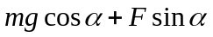, and the net force along (up) the ramp is
In order to move the box, this net force must be greater than zero. Solving for F,
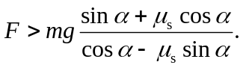
Since F is the magnitude of a force, F must be positive, and so the denominator of this expression must be positive, or 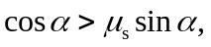 and 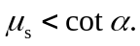 b) Replacing 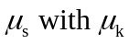 with in the above expression, and making the inequality an equality,
